**OUTPUT SCREENSHOTS**

**CODING SCREENSHOT:**

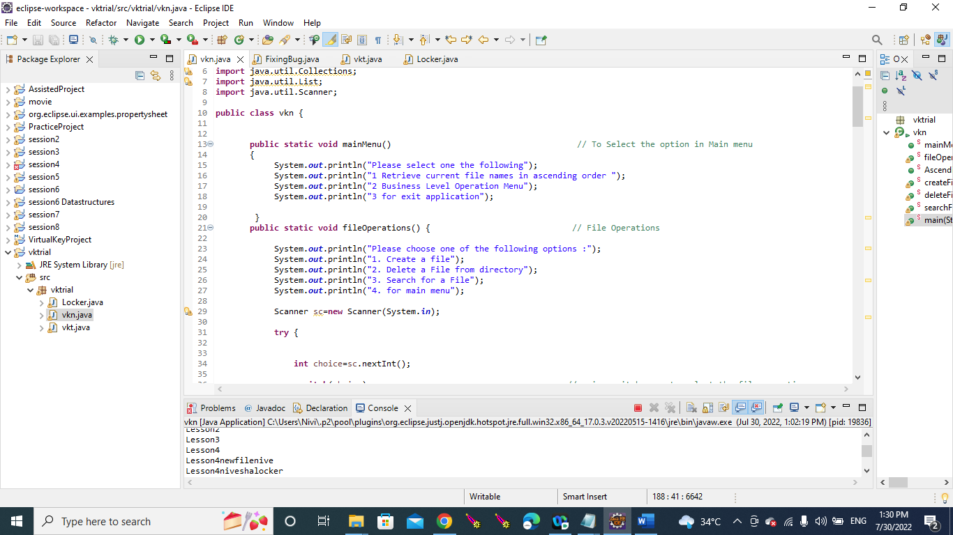

1. **Retrieving the file names in an ascending order**

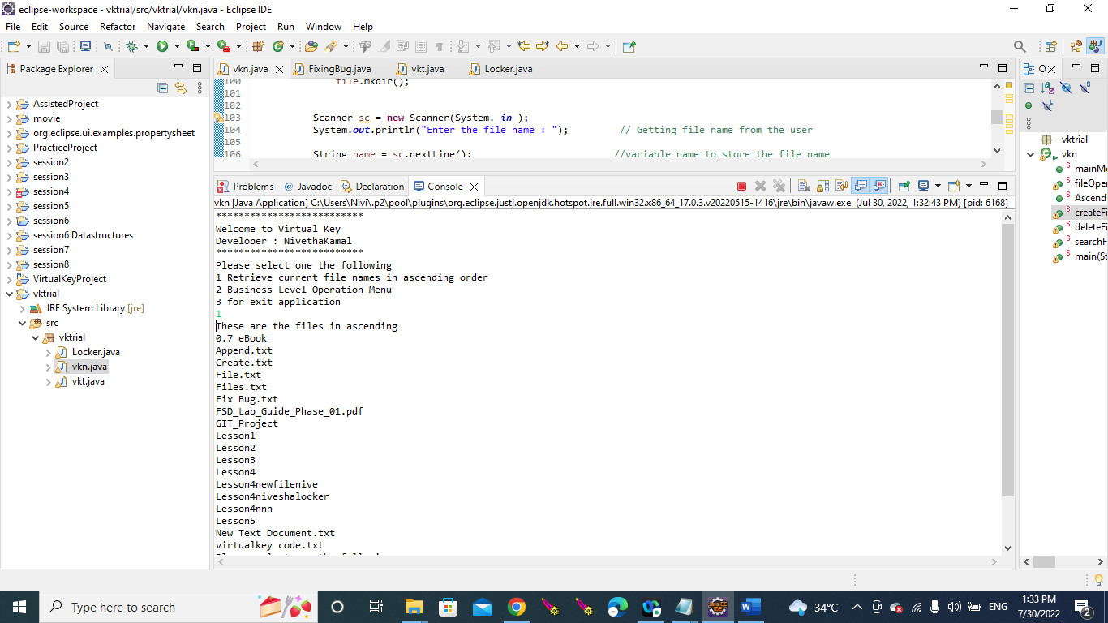

1. **To add a user specified file to the application**

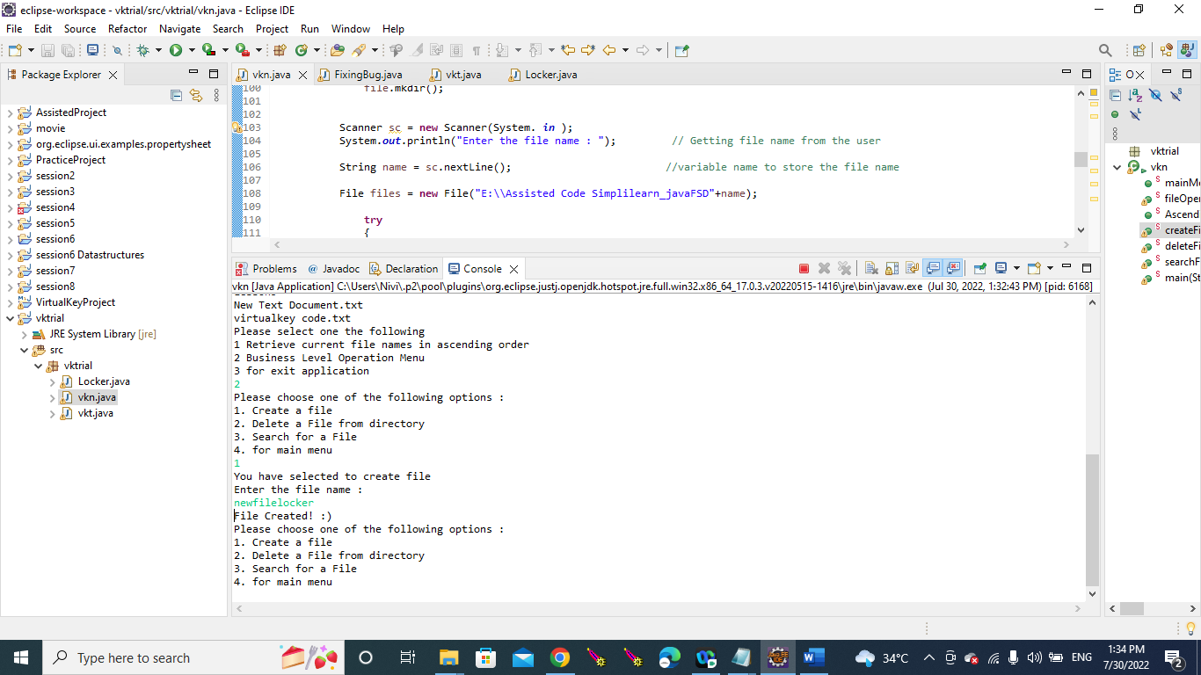

1. **To delete a user specified file from the application**

1. **To search a user specified file from the application**

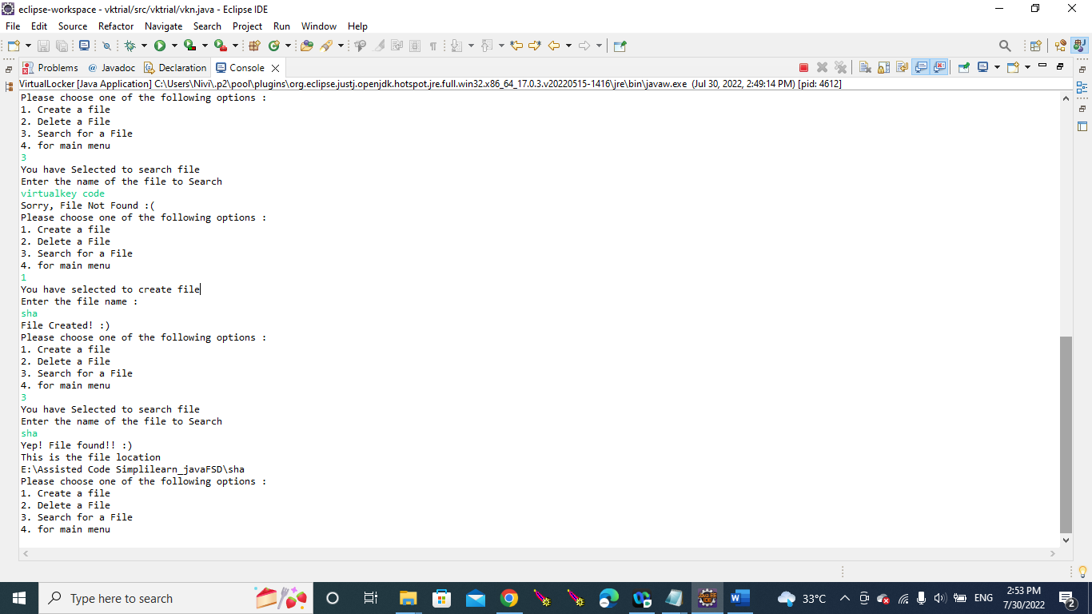

1. **close the application**

